A000-AM,C-Taino-Pendant-Anthropomorphic Owl-Manatee Bone-1000 CE

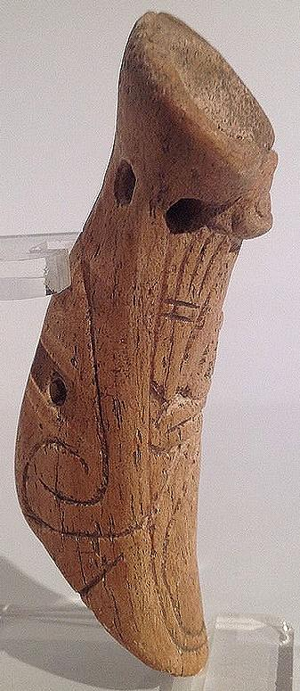- 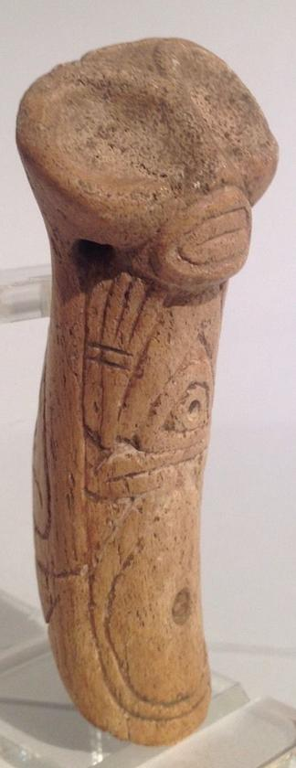 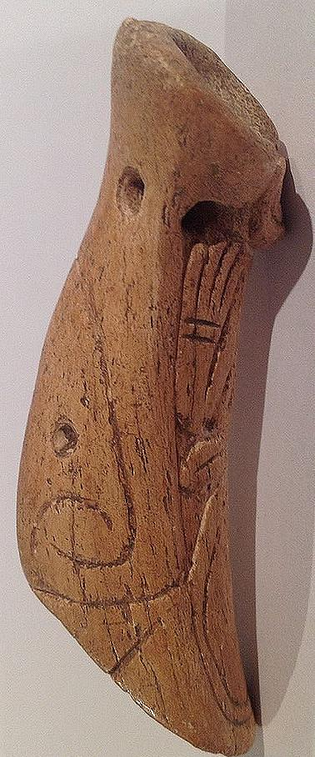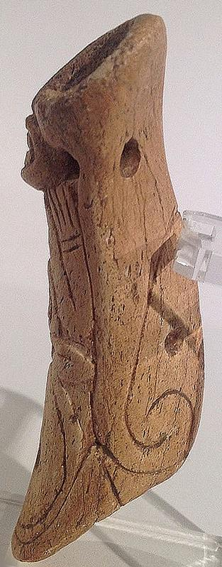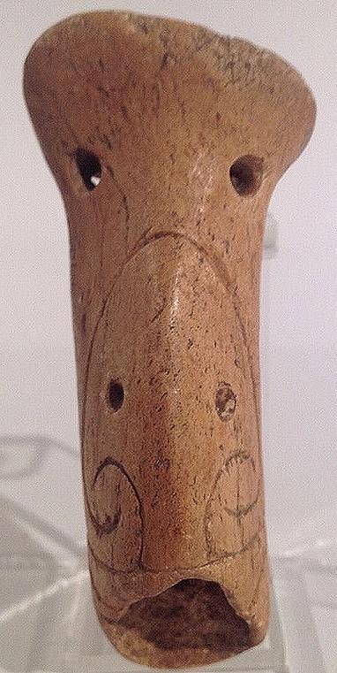

Figs. 1-5. AM,C-Taino-Pendant-Anthropomorphic Owl-Manatee Bone-1000 CE

Case No.: 18

**Accession No.**

**Formal Label:** AM,C-Taino-Pendant-Anthropomorphic Owl-Manatee Bone-1000 CE

**Display Description:**

**LC Classification: F 1909**

**Date or Time Horizon:**

**Geographical Area:**

**Map:**

**GPS coordinates:**

**Cultural Affiliation:**

**Media:**

**Dimensions:**

**Weight:**

**Condition:**

**Provenance:**

**Discussion:**

**References:**